Verify Approval Before Use


Form

CBP/Area: | Worldwide | Form

Document Author: | Danny Foley

Trans-Tech Definition of (Pb) – Free

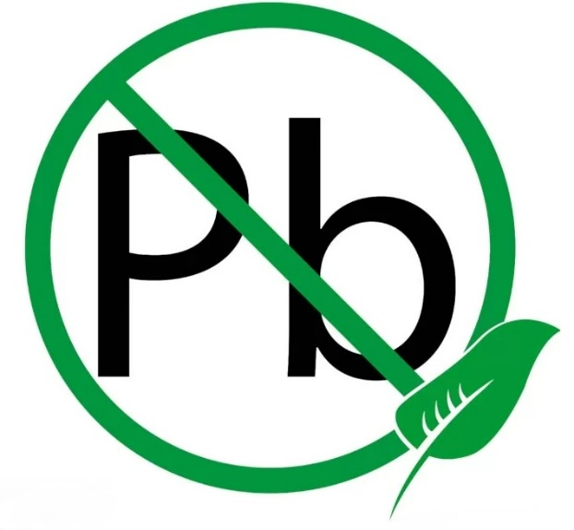
Products designated as Trans-tech Lead (Pb)-Free conform to the regulatory and industry requirements as identified below:
• EU RoHS 2 (recast)¹ and RoHS 3² compliant
• PFOS³ compliant
• REACH⁴ compliant
— Below threshold for Candidate List of Substances of Very High Concern for Authorization
and Annex XVII

1. Directive 2011/65/EU
2. Directive (EU) 2015/863
3. 2006/122/EC
4. EC 1907/2006

